Sign- Up Genius Instructions
- Go to the East High School web page and Click on the Button named Sign Up Genius or copy and paste this link into your browser:
- https://www.signupgenius.com/go/5080B4BA8AF28A31-parent12

- Enter the Sign Up Access Code 2019EHS to go to the East High School Parent Teacher Conference Sign Up.

Access Code Required
- You must enter an access code to view the sign up page "East High School Parent Conferences." The access code is different than your SignUpGenius.com account password and should have been provided to you by the creator of the sign up page.

Access Code:

- Select your first teacher, date and time. The teachers are listed alphabetically by Last name. You can see more teacher names by scrolling down the page.

- Click on the Sign Up button once you find the correct teacher and time.
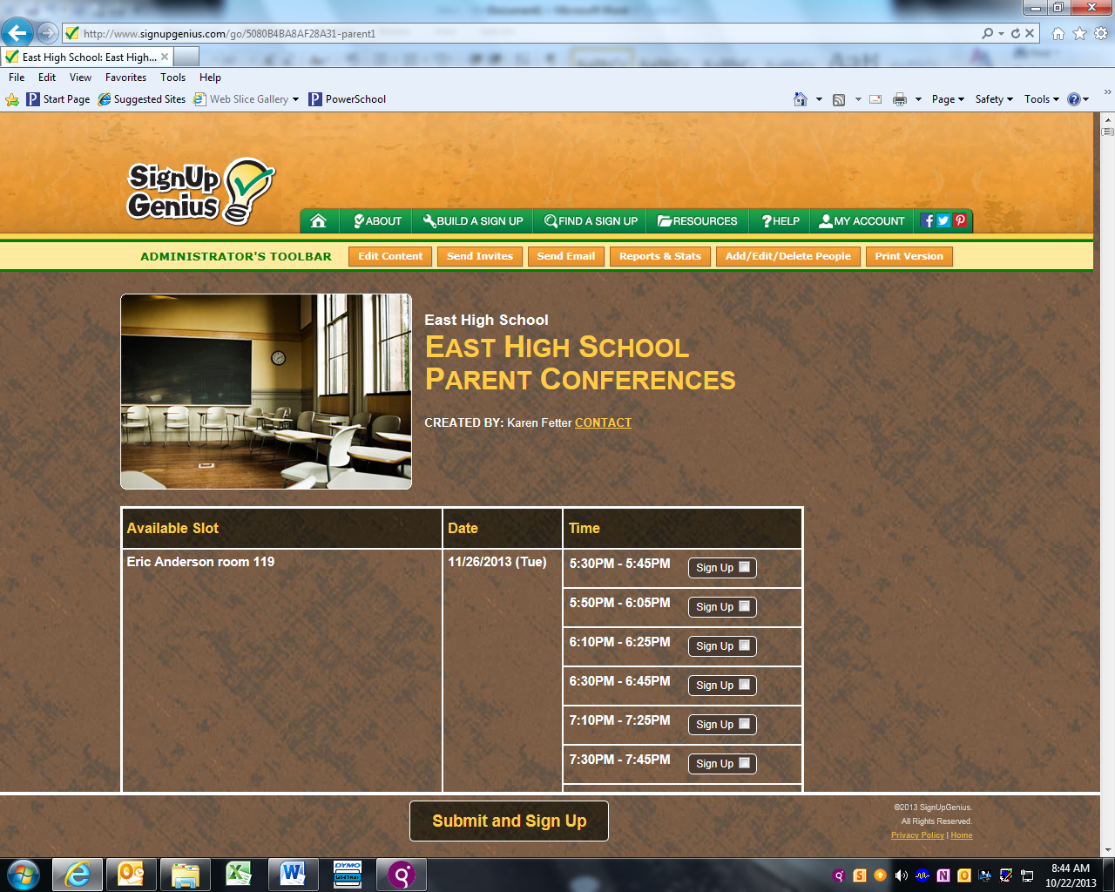
- Type your Student’s First and Last name in “Student Name”
- Click on the Submit and Sign Up Now button
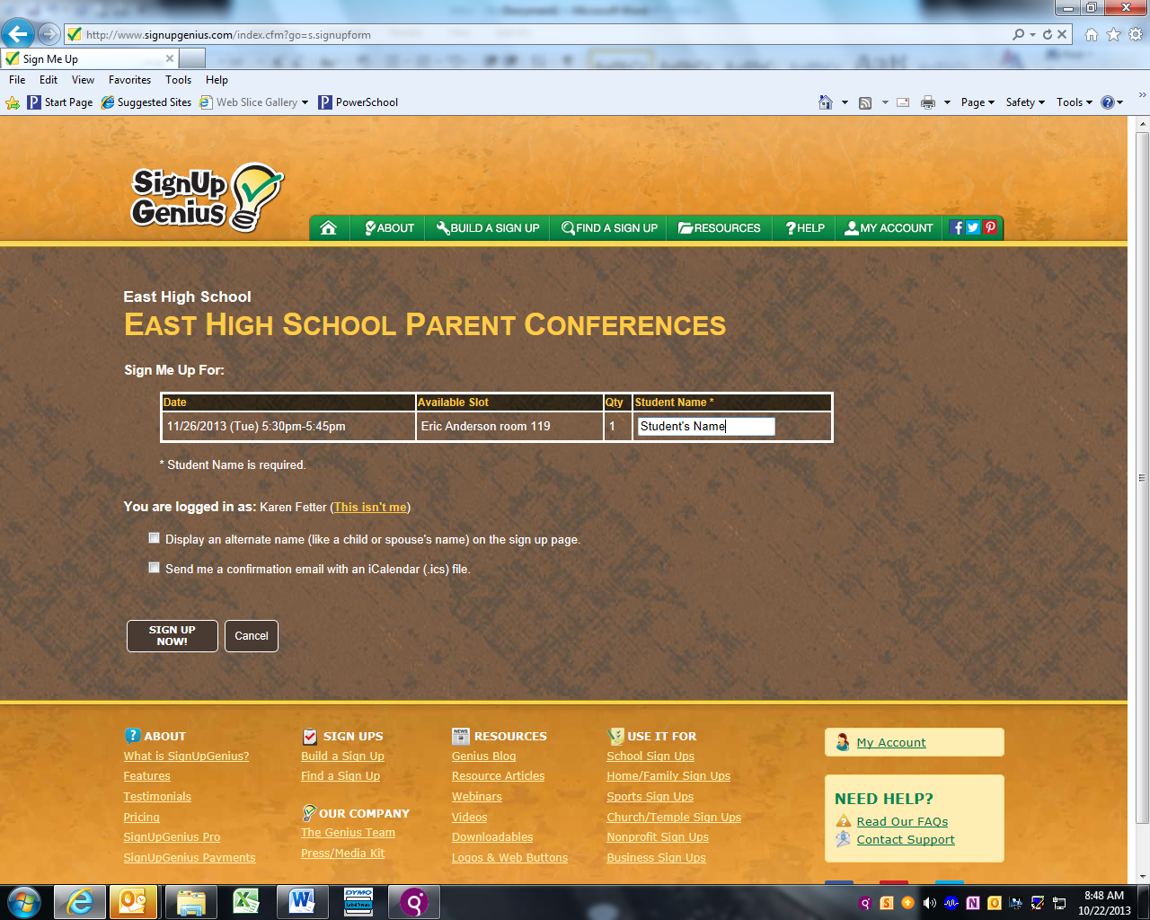
- The next screen will confirm your sign up and allow you the option to add your conference to your online calendar. It is recommended you select the 2nd option, “I’ll quickly create a free Sign-up Genius account. If you check the “I don’t want an account” option, you will not be able to view your schedule at a later time.

- To sign up for more conferences click on the Return to Sign Up button.

- When you are finished your signups you can click on “logout” at the top right to exit the program or go the “My Account” tab at the top and click on “My sign ups” to view your conference schedule summary. Here you can also edit or delete a conference.

